INDEPENDENT UNIVERSITY, BANGLADESH
Department of Electrical and Electronic Engineering
EEE 234 — Electronics
PROJECT 5
Light-Activated Automatic Street Light with
Microcontroller-Based Fault Detection
Design, Analysis, Proteus 8 Simulation and Hardware Implementation
Submitted by
Mir Erfan Kabir Rafi

Student ID: 2411830 ;Section: 01
Submitted to
Dr. Kazi Naziba Tahsin

Abstract
This report presents the design, analysis, simulation and physical implementation of an automatic street light controller that switches a lamp on when ambient light falls below a set level and off again at daybreak. The sensing element is a light-dependent resistor (LDR) in a voltage divider; the decision element is one half of an LM358 dual operational amplifier operating as a comparator. A potentiometer sets the switching threshold, a positive-feedback resistor introduces hysteresis so that the output cannot chatter near the trip point, and a capacitor at the sensing node rejects brief optical transients such as passing headlights. The comparator output drives a BC547 transistor which energises a 12 V relay; the relay contact switches the lamp, and a freewheeling diode protects the transistor from coil back-EMF. Two indicator LEDs report the sensor state, and a two-switch arrangement provides manual force-on and force-off override independent of the sensor.
The complete circuit was captured and simulated in Proteus 8. The netlist passed Electrical Rule Check with no errors and all four operating states were verified. Measured node voltages give a hysteresis band of approximately 0.53 V referred to the sensing divider, corresponding to LDR trip resistances of 9.31 kΩ and 11.11 kΩ.
As an added feature, a microcontroller was integrated as an independent fault monitor that detects a failed lamp, indicator LED, or sensor, raises an audible and visual alarm, keeps a timestamped log, and distinguishes real faults from intentional manual overrides. The monitor was simulated on an ATmega328P in Proteus, where every fault mode was injected and correctly identified, and implemented in hardware on an ESP32 DevKit V1, with the input dividers resized for 3.3 V logic and the fault thresholds recalibrated from bench measurements. The hardware build added a self-hosted Wi-Fi dashboard for remote monitoring, and exposed a measurement limit the simulation could not predict: the ESP32's ADC noise floor made the original current-sense arrangement unreadable, and the fix was a hardware change rather than a software one. Section 9 documents the physical build in full.
Keywords — LDR, comparator, LM358, hysteresis, Schmitt trigger, relay driver, street light, fault detection, ATmega328P, ESP32, ADC noise floor, Proteus.

Table of Contents
Abstract 2
Table of Contents 3
1. Introduction 5
1.1 Background 5
1.2 Problem statement 5
1.3 Objectives 5
1.4 Scope of this report 5
2. Design Methodology 6
2.1 System overview 6
2.2 Light-sensing network (R1, LDR1) 6
2.3 Reference network (RV1) 6
2.4 Comparator with hysteresis (U1:A, R4) 7
2.5 Input noise filtering (C1) 7
2.6 Transistor driver stage (R3, Q1) 8
2.7 Relay, freewheeling diode and load switching (RL1, D1, L1) 8
2.8 Status indication (R2/D2, R5/D3) 9
2.9 Manual override (SW1, SW2) 9
3. Complete Circuit Diagram 9
4. Component Description and Function 11
5. Circuit Operation 12
5.1 Automatic mode 12
5.2 Manual override 12
6. Simulation Setup and Results 13
6.1 Simulation environment 13
6.2 Electrical rule check 13
6.3 Case A — Daylight, automatic mode 13
6.4 Case B — Darkness, automatic mode 14
6.5 Case C — Daylight with forced-on override 14
6.6 Case D — Darkness with master cut-off 15
6.7 Hysteresis measurement 15
6.8 Summary of results 15
7. Performance Analysis 16
7.1 Power budget 16
7.2 Design margins 16
8. Additional Feature: Microcontroller-Based Fault Detection 16
8.1 Design philosophy 17
8.2 Interfacing the microcontroller safely 17
8.3 How each fault is detected 17
8.4 Alerting and indication 18
8.5 Serial fault log 19
8.6 Override-aware operation 19
8.7 Complete circuit with fault-detection subsystem 19
8.8 Simulation and verification 20
9. Hardware Implementation 22
9.1 Choice of microcontroller and consequences 22
9.2 As-built analogue half 22
9.3 As-built monitor half 23
9.4 Calibration procedure 24
9.5 Measured results 25
9.6 Principal hardware finding — a measurement floor, not a threshold error 26
9.7 Wi-Fi monitoring dashboard 27
9.8 Functional verification on hardware 28
9.9 Build and reproduction notes 29
10. Discussion and Limitations 29
11. Future Work 30
12. Conclusion 31
References 31
Appendix A — Added Components for the Fault-Detection Subsystem 33
Appendix B — Firmware 33

1. Introduction

1.1 Background
Street lighting is one of the largest single consumers of municipal electricity. Where lamps are switched by hand or run on a fixed clock, they are frequently left burning after sunrise or switched on before they are needed, which wastes energy and shortens lamp life. An automatic controller removes the human operator from the loop: it measures the ambient light level continuously and switches the lamp only when darkness genuinely warrants it. Because the quantity being measured (illuminance) is analogue and the required output (lamp on or lamp off) is binary, the natural circuit for the job is a comparator, which is the central element of the design presented here.

1.2 Problem statement
A simple comparator driving a lamp has two well-known weaknesses. First, at dusk the ambient light changes very slowly, so the sensing voltage can sit almost exactly at the comparator threshold for several minutes; any small fluctuation then flips the output repeatedly, and the relay and lamp chatter. Second, a momentary optical disturbance — a vehicle's headlights sweeping across the sensor, a bird, a passing shadow — can cross the threshold for a fraction of a second and cause a false transition. Both defects must be addressed for the controller to be usable rather than merely functional.
A third weakness sits above the circuit itself: a working controller is silent about its own health. If the lamp burns out, an indicator fails, or the sensor comes loose, the circuit keeps operating on whatever it is told and gives no sign that anything is wrong. Section 8 addresses this.

1.3 Objectives
- To design a comparator-based light-sensing circuit that switches a lamp ON in darkness and OFF in daylight, with a user-adjustable threshold.
- To eliminate output chatter near the switching point by introducing controlled positive feedback (hysteresis).
- To reject short optical transients by low-pass filtering the sensing node.
- To drive a mains-capable load safely through a transistor and relay, with proper inductive-kickback protection.
- To provide visual indication of the sensor state and a manual override that can force the lamp on or off irrespective of the sensor.
- To capture, simulate and verify the complete design in Proteus 8, and to validate the design equations against measured simulation data.
- To add an independent microcontroller-based fault monitor that reports lamp, indicator and sensor failures without being able to affect the circuit it watches.
- To build and calibrate the design as a physical prototype, and to document honestly where the hardware departs from the simulation.

1.4 Scope of this report
Sections 2 to 7 cover the design, the circuit, the operation of every component, and the complete set of simulation results for the base controller. Section 8 documents the fault-detection subsystem as designed and verified in simulation. Section 9 documents the physical hardware build, its calibration, and its measured results. Sections 10 to 12 discuss limitations, further improvements and conclusions.

2. Design Methodology

2.1 System overview
The controller is built as a chain of five stages. A sensing stage converts illuminance into a voltage. A reference stage produces an adjustable comparison voltage. A comparator stage decides which of the two is larger and produces a saturated logic-level output. A driver stage converts that output into enough current to operate an electromechanical relay. Finally, a load stage routes power to the lamp through the relay contact and through the manual override switches. Indicator LEDs are tapped from the comparator output and from the driver collector so that both the sensor decision and the driver state are visible without instruments.
The supply is a single 12 V rail (BAT1). A single supply was chosen deliberately: it matches what a real outdoor controller would be given, and it forces the design to keep every node inside the LM358's input common-mode range, which extends down to the negative rail and is therefore well suited to single-supply operation.

2.2 Light-sensing network (R1, LDR1)
R1 (10 kΩ) is connected from the +12 V rail to node A, and LDR1 is connected from node A to ground. The LDR is placed in the lower leg so that its resistance rises in darkness and the voltage at node A rises with it. This gives a sensing voltage that increases monotonically with darkness, which is the polarity required to make “dark” correspond to a HIGH comparator output. Neglecting the feedback and filter components for the moment:
V_A = V_CC × R_LDR / (R1 + R_LDR) (1)
The value of R1 was set equal to the LDR's approximate resistance at twilight (about 10 kΩ) so that the divider sits near mid-rail exactly when the decision must be made. This maximises the available voltage swing on either side of the threshold and therefore maximises noise immunity.
Table I — Sensing-node voltage versus LDR resistance
Ambient condition | Approx. R(LDR) | V(A) from (1)
Bright daylight | 1 kΩ | 1.09 V
Overcast day | 5 kΩ | 4.00 V
Twilight (design point) | 10 kΩ | 6.00 V
Late dusk | 20 kΩ | 8.00 V
Full darkness | 100 kΩ | 10.91 V

2.3 Reference network (RV1)
RV1, a 10 kΩ potentiometer, is connected end-to-end across the supply and its wiper feeds the inverting input (pin 2). The wiper voltage is therefore continuously adjustable from 0 V to 12 V, and the trip point of the whole controller can be set anywhere in the LDR's usable range. With the wiper at 50 % the reference is 6.00 V, which by Table I corresponds to a trip at an LDR resistance of about 10 kΩ — the twilight condition. Simulation confirms this: the measured inverting-input voltage is 5.974 V to 6.000 V depending on the exact rail voltage.
Making the threshold adjustable rather than fixed is not a convenience feature. Commercial LDRs have wide manufacturing tolerances, and the light level regarded as “dark enough” depends on the installation site. A fixed resistor divider would require the resistor to be re-selected for every unit; a potentiometer allows the same board to be calibrated in the field. This proved to be the case in hardware — see Section 9.4.

2.4 Comparator with hysteresis (U1:A, R4)
Node A drives the non-inverting input (pin 3) of U1:A and RV1's wiper drives the inverting input (pin 2). The op-amp is used open-loop as a comparator, so its output saturates near the positive rail when V(A) exceeds the reference (darkness) and near ground when it does not (daylight).
R4 (100 kΩ) is connected from the output back to the non-inverting input. This is positive feedback, and it converts the plain comparator into a Schmitt trigger: once the output has switched, the feedback pushes node A further in the direction it has just moved, so the input must travel back through a finite band before the output can return. Applying KCL at node A at the instant of switching, when V(A) equals the reference V(ref):
R_LDR(trip) = V_ref / [ (V_CC − V_ref)/R1 + (V_out − V_ref)/R4 ] (2)
Substituting the simulated output levels, V(OH) = 10.44 V and V(OL) ≈ 0 V, with V(ref) = 6.00 V, R1 = 10 kΩ and R4 = 100 kΩ gives the two trip resistances:
R_LDR(on) = 6 / (0.600 mA − 0.0600 mA) = 11.11 kΩ (darkening) (3)
R_LDR(off) = 6 / (0.600 mA + 0.0444 mA) = 9.31 kΩ (brightening) (4)
Referred back through (1), these correspond to sensing voltages of 6.32 V (upper trip point) and 5.79 V (lower trip point), so the hysteresis band is:
ΔV = 6.32 − 5.79 = 0.53 V (5)
A useful cross-check is the small-signal approximation, in which the band is the output swing divided down by the feedback network and the Thevenin resistance of the sensing node:
ΔV ≈ (V_OH − V_OL) × R_th / (R_th + R4) = 10.44 × 5.0 / 105.0 ≈ 0.50 V (6)
The two methods agree to within 6 %, which validates the choice of R4. The band is deliberately narrow. A wider band (a smaller R4) would make the lamp switch on and off at visibly different light levels, which is unrealistic for a dusk sensor; a much narrower band (a larger R4) would not provide enough immunity to keep the relay from chattering. 100 kΩ places the controller at a defensible compromise: roughly a 19 % window in LDR resistance about the trip point.

2.5 Input noise filtering (C1)
C1 (10 µF) is placed from node A to ground, in parallel with the LDR. Together with the Thevenin resistance seen at node A it forms a first-order low-pass filter. At the trip point the LDR is about 10.2 kΩ, so:
R_th = R1 ∥ R_LDR ∥ R4 = 10 k ∥ 10.2 k ∥ 100 k = 4.81 kΩ (7)
τ = R_th × C1 = 4.81 kΩ × 10 µF = 48.1 ms (8)
f_c = 1 / (2π R_th C1) = 3.3 Hz (9)
The filter's role is complementary to that of the hysteresis, and the distinction matters. Hysteresis rejects small-amplitude noise of any duration; the filter rejects short-duration disturbances of any amplitude. A car's headlight beam sweeping the sensor is a large, brief event: it would cross the hysteresis band easily, but it is far shorter than 48 ms of settling and is therefore attenuated before it reaches the comparator. The natural day-night transition, by contrast, takes tens of minutes and passes through the filter unaffected.
This filtering action cannot be demonstrated by moving a light-source slider with a mouse, because a manual slider movement is itself far slower than the filter's time constant. Verifying it properly requires an injected pulse and a transient graph, which is identified in Section 11 as further work.

2.6 Transistor driver stage (R3, Q1)
The LM358 cannot source the tens of milliamperes a relay coil requires, so Q1 (BC547, NPN) is used as a low-side switch in common-emitter configuration. R3 (1 kΩ) limits the base current:
I_B = (V_OH − V_BE) / R3 = (10.44 − 0.7) / 1 kΩ = 9.74 mA (10)
The relay's coil current sets the required collector current. Taking the nominal coil resistance of the 12 V G2R-1-E variant as approximately 275 Ω:
I_C = (V_CC − V_CE(sat)) / R_coil = (12 − 0.2) / 275 Ω ≈ 43 mA (11)
β_forced = I_C / I_B = 43 / 9.74 ≈ 4.4 (12)
The forced beta of 4.4 is far below the BC547's minimum current gain of roughly 110, so the transistor is driven deep into saturation rather than being left in the active region. This is the desired condition for a switch: V(CE) collapses to a few hundred millivolts, dissipation in Q1 is negligible, and the full supply appears across the coil. The collector current of 43 mA is also comfortably inside the BC547's 100 mA absolute maximum, so no derating or heatsinking is required.

2.7 Relay, freewheeling diode and load switching (RL1, D1, L1)
RL1 provides galvanic isolation between the low-voltage control electronics and the lamp circuit. This is the main reason a relay is preferred to a transistor for the final load: a real street lamp is a mains-voltage device, and the relay contact keeps that voltage entirely separate from the 12 V logic. In this simulation a 12 V lamp is used in place of a mains fixture, but the topology is unchanged.
The lamp is wired to the normally-open (NO) contact, not the normally-closed (NC) contact. This is a critical detail: the NC contact conducts when the coil is de-energised, which would produce a lamp that burns during the day and switches off at night, exactly inverting the intended behaviour. Using the NO contact makes lamp current flow only while the coil is energised, i.e. only in darkness.
D1 (1N4007) is connected across the coil with its cathode toward +12 V. When Q1 turns off, the collapsing magnetic field in the coil attempts to maintain current, generating a reverse voltage spike that can be many times the supply voltage and would destroy Q1. D1 becomes forward-biased under this condition and provides a circulating path for the coil current, clamping the spike to roughly one diode drop above the rail. Its orientation is therefore not optional — reversed, it would short the supply whenever Q1 conducts.

2.8 Status indication (R2/D2, R5/D3)
D2 (red) is driven from the comparator output through R2 (1 kΩ) and lights whenever the sensor reports darkness:
I_D2 = (V_OH − V_F) / R2 = (10.44 − 2.0) / 1 kΩ ≈ 8.4 mA (13)
D3 (green) is driven from Q1's collector node through R5 (1 kΩ) and lights whenever the driver is off, i.e. in daylight. Its current path runs through the relay coil, so the coil resistance appears in series:
I_D3 = (V_CC − V_F) / (R_coil + R5) = (12 − 2.1) / 1275 Ω ≈ 7.8 mA (14)
This 7.8 mA does flow through the relay coil, and it is worth confirming that it cannot cause a false pick-up. The coil requires on the order of 43 mA to operate, and relay specifications typically guarantee operation only above about 75 % of rated coil voltage; 7.8 mA is roughly one-fifth of the operating current and is therefore far below the must-operate threshold. The relay remains reliably released. When Q1 saturates, its collector falls to a few hundred millivolts, D3 loses its forward bias and extinguishes, so the two LEDs are always in opposite states and give an unambiguous day/night readout.

2.9 Manual override (SW1, SW2)
Two switches in series with the lamp provide a three-state override. SW1 selects the lamp's source: either the relay's NO contact (automatic mode) or the +12 V rail directly (forced-on mode, bypassing the sensor entirely). SW2 acts as a master cut-off in series with the lamp, and opening it forces the lamp off regardless of both the sensor and SW1.
The need for two switches rather than one follows from a logical distinction that is easy to overlook. A single SPDT switch can only choose between “let the sensor decide” and “force on”; it cannot force the lamp off, because in automatic mode the sensor legitimately turns the lamp on at night. “Automatic” and “off” are not the same state. A genuine override must be able to defeat the sensor in both directions, which requires a second, independent series element. Real street-lighting control panels use exactly this arrangement, giving maintenance staff the ability to light a lamp in daylight for testing and to extinguish it at night for servicing.

3. Complete Circuit Diagram
The circuit is presented in two halves so that each stays readable. Fig. 1 is the sensing side, which decides whether it is day or night. Fig. 2 is the output side, which acts on that decision and switches the lamp. Fig. 3 shows the same design as a single schematic captured in Proteus 8, containing all eighteen parts: the sensing network (R1, LDR1, C1), the reference (RV1), the comparator and its feedback path (U1:A, R4), the indicator branches (R2/D2, R5/D3), the driver (R3, Q1), the relay and its protection diode (RL1, D1), the override switches (SW1, SW2), the lamp (L1) and the supply (BAT1).
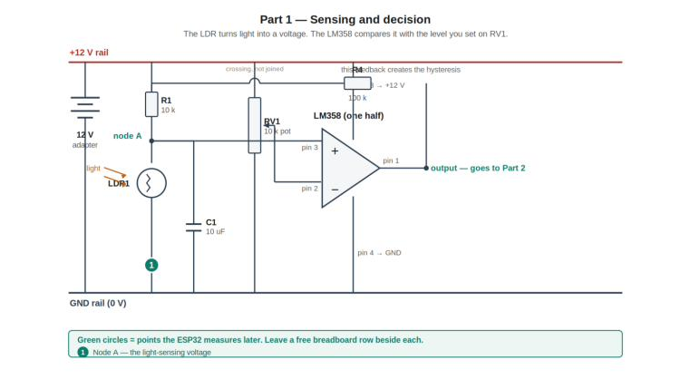
Fig. 1 — Sensing and decision stage: the LDR divider, the threshold potentiometer, and the LM358 comparator with its hysteresis feedback.
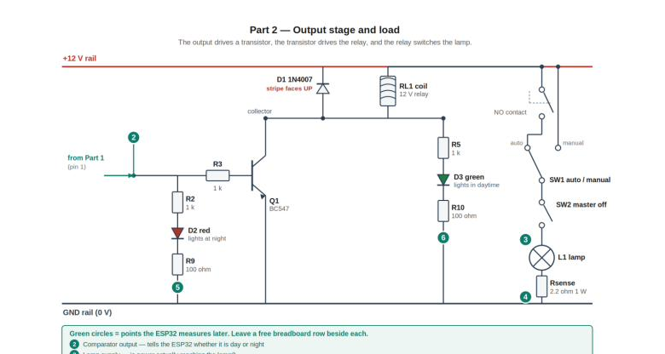
Fig. 2 — Output stage and load: the BC547 driver, the relay and its freewheeling diode, the two indicator LEDs, the override switches and the lamp.
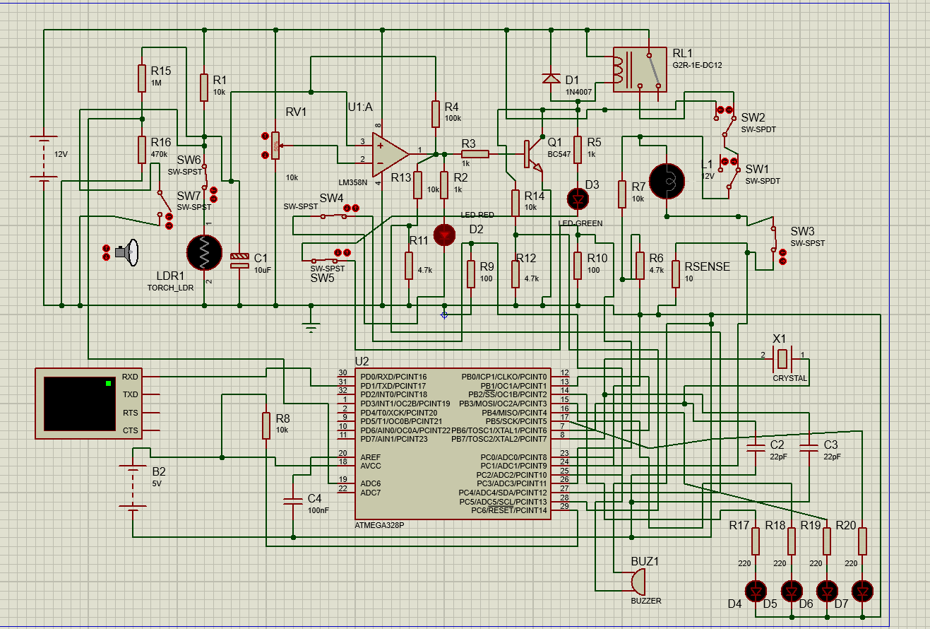
Fig. 3 — Complete schematic of the light-activated automatic street light controller (Proteus 8).

4. Component Description and Function
Table II lists every component in the design together with its value and the specific function it performs. The functional descriptions are not generic definitions; each states why that part is present in this circuit and what would fail without it.
Table II — Component list and functional role
Ref. | Device | Value | Function in this circuit
BAT1 | BATTERY | 12 V | Single supply rail for the entire controller and the lamp.
R1 | RES | 10 kΩ | Upper leg of the sensing divider; sets the divider mid-point at the twilight LDR resistance.
LDR1 | TORCH_LDR | — | Light sensor. Resistance rises in darkness, raising the voltage at node A.
C1 | CAP | 10 µF | Low-pass filter at node A; rejects brief optical transients (τ ≈ 48 ms, f_c ≈ 3.3 Hz).
RV1 | POT-HG | 10 kΩ | Adjustable reference; sets the light level at which the lamp switches. Wiper at 50 % gives 6.0 V.
U1:A | LM358N | — | Open-loop comparator. Compares the sensing voltage against the reference and saturates its output.
R4 | RES | 100 kΩ | Positive-feedback resistor. Creates the 0.53 V hysteresis band that prevents chatter at the trip point.
R2 | RES | 1 kΩ | Current limiter for D2 (≈ 8.4 mA).
D2 | LED-RED | — | Night indicator. Lit whenever the comparator output is HIGH (sensor reports darkness).
R3 | RES | 1 kΩ | Base resistor for Q1; sets I_B = 9.74 mA, driving the transistor into hard saturation.
Q1 | BC547 | NPN | Low-side switch. Supplies the ≈ 43 mA of coil current the op-amp cannot source.
RL1 | G2R-1E-DC12 | 12 V coil | Isolates the lamp circuit from the control electronics; its NO contact switches the lamp.
D1 | 1N4007 | — | Freewheeling diode. Clamps the coil's back-EMF spike when Q1 turns off, protecting the transistor.
R5 | RES | 1 kΩ | Current limiter for D3 (≈ 7.8 mA, flowing through the coil).
D3 | LED-GREEN | — | Day indicator. Lit whenever Q1 is off (sensor reports daylight).
SW1 | SW-SPDT | — | Mode selector: relay contact (automatic) or +12 V rail (forced on).
SW2 | SW-SPDT | — | Master cut-off in series with the lamp; opening it forces the lamp off.
L1 | LAMP | 12 V | The street lamp load.

5. Circuit Operation

5.1 Automatic mode
With SW1 selecting the relay contact and SW2 closed, the controller runs autonomously. In daylight the LDR's resistance is low, node A sits near 1 V, the comparator's non-inverting input is below the 6 V reference, and the output saturates near 0 V. Q1 has no base drive, the coil is de-energised, the NO contact is open and the lamp is dark; the collector sits near the rail, so the green LED is lit.
As dusk falls the LDR's resistance rises and node A climbs. When it crosses the upper trip point of 6.32 V the comparator output snaps HIGH to 10.44 V. Positive feedback through R4 immediately lifts node A further, to a measured 8.12 V, which drives the transition to completion and prevents any oscillation at the boundary. Base current flows, Q1 saturates, the coil energises, the NO contact closes and the lamp lights. The red LED lights simultaneously and the green LED extinguishes.
At dawn the process reverses, but not at the same light level: the output cannot return LOW until node A has fallen below 5.79 V, because the feedback is still holding it up. That 0.53 V gap is the hysteresis, and it is what guarantees a single clean transition rather than a burst of switching.
Table III — Automatic-mode operating states
Condition | R(LDR) | U1:A output | Q1 | D2 | D3 | Lamp L1
Daylight | ≈ 1 kΩ | LOW (≈ 0 V) | Off | Off | On | OFF
Darkness | ≈ 100 kΩ | HIGH (10.44 V) | Saturated | On | Off | ON

5.2 Manual override
The two switches give three usable states, summarised in Table IV. In both override states the indicator LEDs continue to report the true sensor decision, because they are tapped upstream of the switches. This is a useful diagnostic property: an operator can see at a glance that the lamp is on only because it has been forced on, and that the sensor itself still believes it is daytime. It is also why the LED monitoring in Section 8 needs no override-awareness of its own.
Table IV — Override matrix
SW1 | SW2 | Lamp behaviour | Intended use
Relay (auto) | Closed | Follows the sensor | Normal unattended operation.
+12 V (manual) | Closed | Forced ON, sensor ignored | Testing or servicing a lamp during daylight.
Either | Open | Forced OFF, sensor ignored | Isolating a lamp at night for maintenance.

6. Simulation Setup and Results

6.1 Simulation environment
The circuit was captured and simulated in the Proteus 8 Design Suite using interactive (animated) simulation. Ambient light is modelled by the TORCH_LDR component, whose illumination is controlled by an on-screen light source; raising the source's control voltage simulates daylight and lowering it simulates darkness. Real-time voltage probes (RTVPROBE) were placed at the sensing node and at the comparator output to record node voltages during the sweep.

6.2 Electrical rule check
Before any simulation was run, the design was validated with Proteus's Electrical Rule Check. The netlist generated without error and no rule violations were reported, confirming that there are no shorted nets, floating pins or unconnected power rails in the captured schematic.

6.3 Case A — Daylight, automatic mode
With the light source at maximum intensity and SW1 in the automatic position, the LDR resistance is low, the comparator output is LOW, and the relay remains released. The green LED is lit and both the red LED and the lamp are dark, which matches the predicted daylight row of Table III.
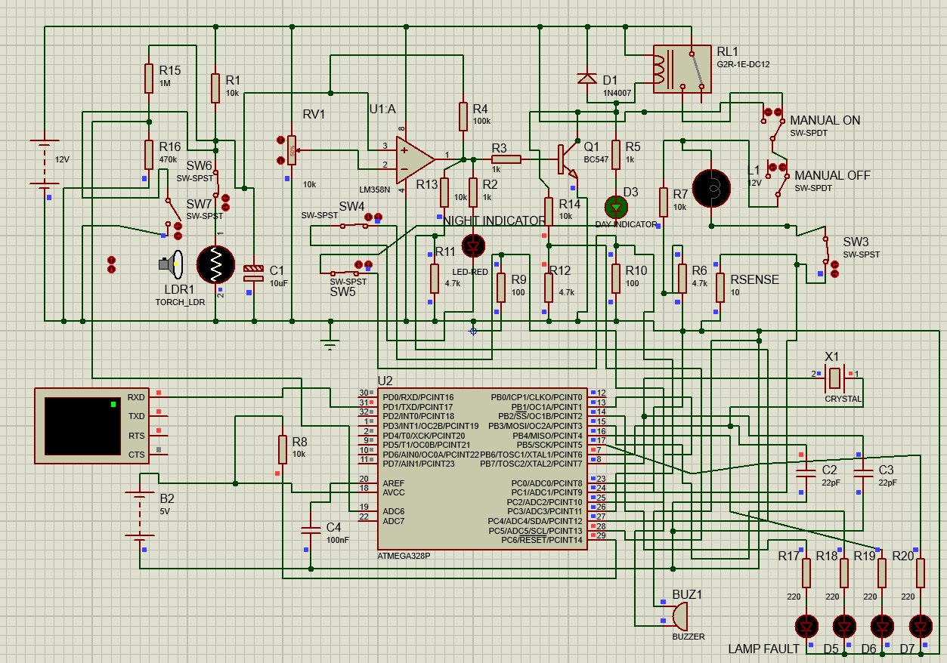Fig. 4 — Case A: daylight, automatic mode — lamp OFF, green (day) LED lit.

6.4 Case B — Darkness, automatic mode
Reducing the light source to zero raises the LDR resistance past the upper trip point. The comparator output snaps HIGH, Q1 saturates, the relay energises and its NO contact closes, and the lamp lights. The red LED is lit and the green LED is extinguished. This is the intended dusk-to-dawn behaviour.
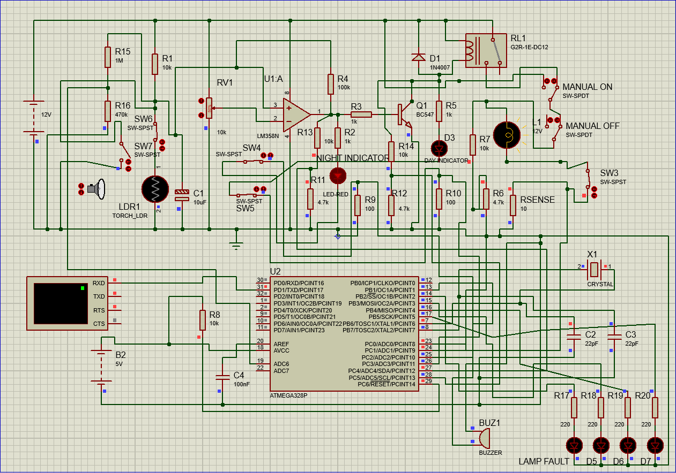
Fig. 5 — Case B: darkness, automatic mode — lamp ON, red (night) LED lit.

6.5 Case C — Daylight with forced-on override
With the light source still at maximum intensity, SW1 was moved to the +12 V position. The lamp lights even though the sensor correctly continues to report daylight, as confirmed by the green LED remaining lit. This demonstrates that the override successfully bypasses the relay and the sensing chain.
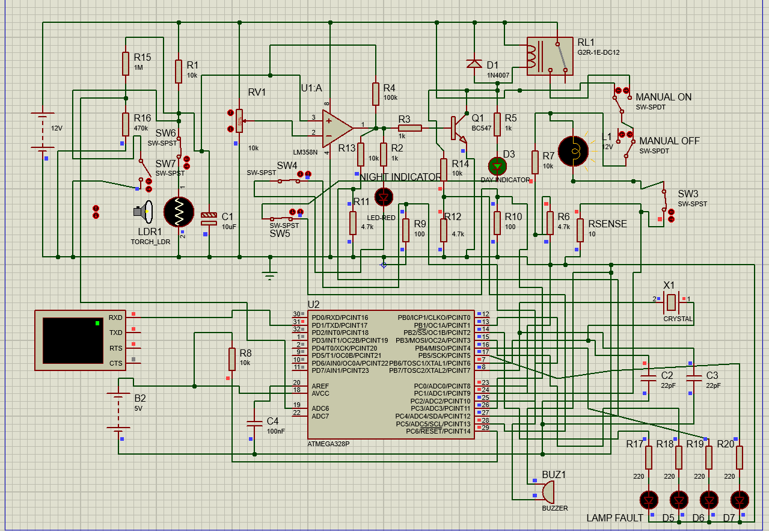
Fig. 6 — Case C: daylight with SW1 in the manual position — lamp forced ON while the day indicator remains lit.

6.6 Case D — Darkness with master cut-off
With the light source at zero and SW1 returned to automatic, SW2 was opened. The lamp is extinguished even though the sensor correctly reports darkness, as confirmed by the red LED remaining lit. This demonstrates the force-off capability that a single-switch override cannot provide.
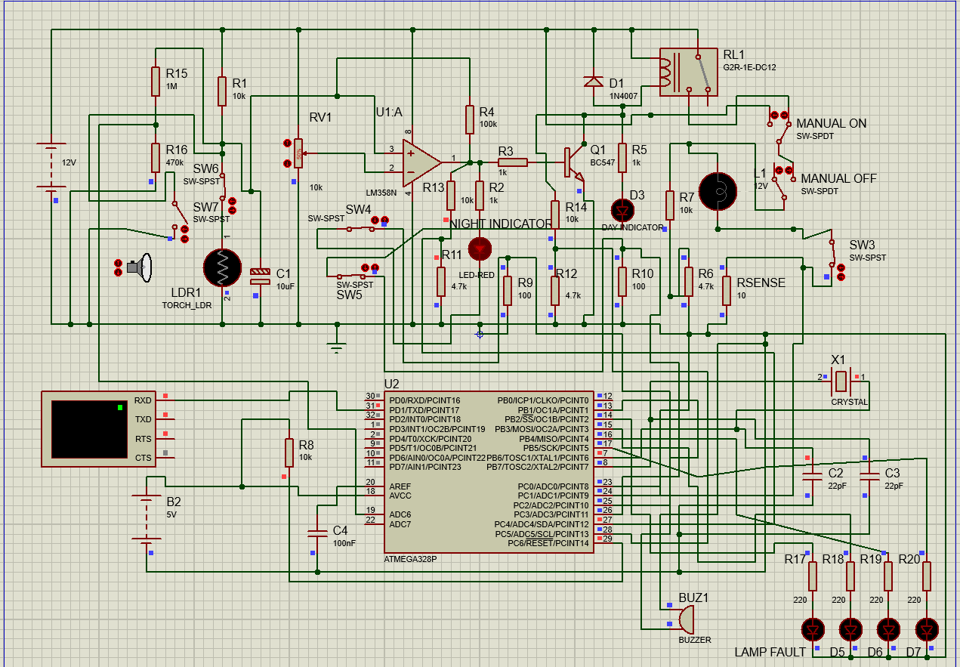Fig. 7 — Case D: darkness with SW2 open — lamp forced OFF while the night indicator remains lit.

6.7 Hysteresis measurement
The terminal voltages of U1:A were recorded immediately after each transition. Table V lists the results. In both states the non-inverting input has been displaced well clear of the 6 V reference by the feedback through R4 — upward by 2.15 V after switching on and downward by 2.13 V after switching off. This displacement is the regenerative action of the Schmitt trigger, and it is what makes a return transition impossible without a substantial change in illumination.
Table V — Measured U1:A terminal voltages after switching
State | V(+IP) | V(−IP) | V(OP) | V+
After switching ON (dark) | 8.119 V | 5.974 V | 10.44 V | 11.95 V
After switching OFF (bright) | 3.871 V | 6.000 V | −11.14 mV | 12.00 V

The measured output levels are the values used in (3), (4) and (6). The close agreement between the two independent estimates of the hysteresis band — 0.53 V from the exact KCL solution and 0.50 V from the small-signal approximation — confirms that the circuit behaves as the design equations predict.

6.8 Summary of results
All four operating states were reproduced exactly as designed, the netlist passed rule checking, and the measured hysteresis agrees with theory to within 6 %. The simulation therefore validates both the topology and the component values chosen in Section 2.

7. Performance Analysis

7.1 Power budget
Table VI estimates the current drawn by the control electronics in each state, excluding the lamp itself. The relay coil dominates the night-time budget, accounting for roughly two-thirds of the total control current.
Table VI — Estimated control-circuit current (lamp excluded)
Branch | Daylight (lamp off) | Darkness (lamp on)
Sensing divider (R1, LDR1) | 1.09 mA | 0.11 mA
Reference divider (RV1) | 1.20 mA | 1.20 mA
LM358 quiescent | ≈ 0.70 mA | ≈ 0.70 mA
Red LED branch (R2, D2) | — | 8.40 mA
Green LED branch (R5, D3) | 7.80 mA | —
Base drive (R3) | — | 9.74 mA
Relay coil (RL1) | — | 43.0 mA
Total control current | ≈ 10.8 mA | ≈ 63.2 mA
Control power at 12 V | ≈ 0.13 W | ≈ 0.76 W

The lamp's own consumption must be added to the night-time figure and is set by the lamp's rating, P_L = V² / R_L. For the 12 V lamp model used in simulation this dominates the total draw by an order of magnitude, which is expected: the point of the controller is to ensure that this large load is energised only when it is actually needed.
Note on hardware. These are simulation figures for a relay-switched filament lamp. The physical prototype uses an LED load and does not populate the relay, so its measured currents are far lower. See Section 9.5.

7.2 Design margins
- Q1 collector current (43 mA) is 43 % of the BC547's 100 mA absolute maximum.
- Forced beta of 4.4 is well below the device's minimum hFE of about 110, guaranteeing saturation across normal parameter spread.
- The green LED's 7.8 mA holding current through the coil is roughly one-fifth of the relay's operating current, safely below the must-operate threshold.
- All sensing-node voltages (1.09 V to 10.91 V) lie within the LM358's single-supply input common-mode range.

8. Additional Feature: Microcontroller-Based Fault Detection
The controller described in Sections 2 to 7 performs its job correctly, but it is silent about its own health. If the lamp burns out, or an indicator LED fails, or the LDR comes loose, the circuit keeps operating on whatever it is told and gives no sign that anything is wrong. In a single installation a person would eventually notice; across a network of thousands of street lights, nobody can inspect each pole by hand. This section describes a fault-detection layer added on top of the existing design that watches the circuit and reports failures automatically. Everything in the earlier sections remains unchanged — this subsystem is added alongside it, not in place of it.
This section documents the subsystem as designed and verified in simulation on an ATmega328P. Section 9 documents the reduced two-channel version implemented in hardware on an ESP32, and explains why the channel count changed.

8.1 Design philosophy
Two principles shaped the whole addition. First, the monitor is a separate observer, not a redesign. The original analogue circuit still runs entirely on its own; if the microcontroller or its program were removed, the street light would keep working exactly as before. The part that watches for faults must never be able to cause one. Second, the monitor only ever reads the circuit, never drives it. Every connection from the circuit to the microcontroller is a high-impedance tap that draws negligible current, so measuring a node cannot disturb it — the same reasoning that lets the op-amp read the sensing divider without loading it.
Both principles carried through unchanged into the hardware build, and they are the reason the dashboard's manual override button in Section 9.7 was left as a deliberate placeholder.

8.2 Interfacing the microcontroller safely
The ATmega328P runs on 5 V and its input pins tolerate at most 5 V, while the street-light circuit runs on 12 V. Every 12 V node that the microcontroller needs to read is therefore first passed through a resistor voltage divider that scales it into the safe range. A 10 kΩ and 4.7 kΩ pair is used throughout:
V_ADC = 12 V × 4.7 kΩ / (10 kΩ + 4.7 kΩ) = 3.84 V (15)
This sits comfortably below the 5 V limit with margin to spare. The microcontroller's program reverses this scaling in software by multiplying each divided reading by the same ratio, so it recovers the true node voltage for its decisions. Small sense voltages — those developed across the current-sensing resistors described below — are already well under 5 V and are read directly, without a divider. The microcontroller is given its own 5 V supply (B2) and shares a common ground with the main circuit, which is essential: a voltage reading is only meaningful relative to a shared reference.
A 16 MHz crystal (X1) with two 22 pF capacitors provides the clock, and a 10 kΩ pull-up holds the reset line inactive — the same supporting circuitry found on any Arduino board, since the ATmega328P is the identical chip used inside the Arduino Uno. This allowed the firmware to be written and compiled in the standard Arduino environment and loaded directly into the chip in simulation.
One exception to the divider rule. The node-A tap cannot use the 10 kΩ / 4.7 kΩ pattern. Node A is a high-impedance node, and a divider of that size loads it heavily enough to cap the voltage at about 7.1 V, which makes sensor disconnection undetectable. A monitoring tap on a high-impedance node must itself be high-impedance, so R15/R16 are 1 MΩ / 470 kΩ.

8.3 How each fault is detected
Lamp monitoring. The lamp is the most important part of the system and the single most likely component to fail, since a filament wears out where a resistor essentially does not. A burnt-out lamp has a distinctive signature: voltage is still being applied to it, but no current flows through it. The monitor watches for exactly this. A small 10 Ω sense resistor (Rsense) is placed in the lamp's return path; current through the lamp develops a measurable voltage across it, so a reading near zero means no current is flowing. Separately, the lamp's supply-side voltage is read through a divider. When supply voltage is present but sense voltage is absent, the lamp has failed:
LAMP_FAULT = (V_supply > 6 V) AND (V_sense ≤ 0.30 V) (16)
Because the supply voltage is tapped at the lamp itself — after the manual override switches — this check is automatically correct when the lamp is switched off on purpose: with no voltage reaching the lamp, the first condition is false and no fault is reported.
Indicator LED monitoring. The two indicator LEDs are the system's status display — the thing a person glances at to read its state. A dead status light is worse than useless: if the green “day” LED fails, an observer sees nothing lit and wrongly concludes the system is off. The same current-versus-command test used for the lamp is therefore applied to each LED. A small sense resistor (R9, R10 = 100 Ω) in each LED's path reports whether current is flowing, and the node that commands the LED — the comparator output for the red LED, the transistor collector for the green LED — reports whether it is supposed to be lit. An LED commanded on but drawing no current has failed.
Sensor fault detection. The LDR is the system's eye, and a failed sensor is especially deceptive: if it shorts or comes loose, the whole circuit misbehaves — lamp stuck on all day or off all night — yet every other check still looks fine, because the circuit is faithfully obeying a broken sensor. This fault cannot be caught with a current test, because the LDR has no separate “commanded” signal to compare against; it is itself the source of truth. Instead, the monitor checks whether the sensing voltage sits somewhere a real LDR could ever produce. A genuine LDR always has a finite resistance, so the sensing node can approach the supply rails but never quite reach them. A reading pinned hard against ground means the sensor is shorted; a reading pinned hard against the rail means it is disconnected:
SENSOR_SHORTED = (V_A < 0.5 V) ; SENSOR_OPEN = (V_A > 11.71 V) (17)
The two cases are reported as distinct messages, since a technician benefits from knowing which failure occurred. The upper threshold of 11.71 V was not assumed but calibrated from the circuit itself: in simulation the sensing node read 11.66 V at genuine full darkness and 11.76 V when the LDR was physically disconnected, so the threshold was placed midway between these two measured values. The narrow gap between them is discussed as a limitation in Section 10.

8.4 Alerting and indication
A buzzer (BUZ1) sounds whenever any fault is active, alerting a maintenance person without their needing to watch the panel. It is driven with an on/off beeping pattern rather than a steady tone, because an intermittent beep is recognised as an alarm where a continuous tone tends to fade into background noise and be ignored.
The buzzer announces that something is wrong; four dedicated indicator LEDs (D4–D7) announce what is wrong — one each for the lamp, the red LED, the green LED, and the sensor. This lets a technician go straight to the correct fault instead of diagnosing from scratch.
Table VII — Fault-indicator LED assignment (simulation)
LED | Driven from | Indicates
D4 | PB2 (pin 14) | Lamp fault — powered but not conducting
D5 | PB3 (pin 15) | Red (night) indicator LED failed
D6 | PB4 (pin 16) | Green (day) indicator LED failed
D7 | PB5 (pin 17) | Sensor fault — shorted or disconnected

8.5 Serial fault log
Alongside the lights and buzzer, the monitor prints readable status messages to a serial terminal, forming a log of the sort a real monitoring installation keeps. Two design choices make this log useful rather than noisy. First, messages are event-based: a line is printed only when a fault begins or clears, not repeatedly while it persists, so the log records transitions like “FAULT: Lamp not conducting” and later “CLEARED: Lamp fault resolved,” each with a timestamp. Second, a short heartbeat line is printed every ten seconds even when nothing is wrong. This is deliberate: without it, a silent terminal would be ambiguous between “all is well” and “the monitor itself has crashed.” The heartbeat removes that ambiguity and doubles as a periodic snapshot of every measured voltage.

8.6 Override-aware operation
The manual override switches from the base design pose a subtle problem for any fault monitor: when an operator deliberately switches the lamp off, a naive detector would see “no lamp current” and wrongly raise a lamp fault. A monitor that cries wolf during normal operation is quickly ignored, so the design must distinguish “operator turned it off” from “bulb burnt out.”
For the lamp check this is already handled, as noted in 8.3: because supply voltage is measured after the override switches, an intentional shut-off removes the supply voltage and the fault condition is simply never met. Beyond that, the monitor also actively recognises override activity, without needing to read the switch positions directly — which is not reliably possible, since one throw of the mode switch tracks the variable relay signal. Instead it compares what the sensor logic wants (the transistor-collector voltage) against what is actually happening at the lamp (the supply voltage). In normal automatic operation these always agree. A disagreement can only mean an operator has intervened: lamp powered while the sensor reads daylight indicates a forced-on override; lamp unpowered while the sensor reads darkness indicates a forced-off override or cut-off. These are logged as informational MODE messages and deliberately do not trigger the buzzer or fault LEDs, because an intentional override is not a malfunction.

8.7 Complete circuit with fault-detection subsystem
Fig. 8 shows the full circuit with the monitoring subsystem added. The original street-light controller occupies the upper portion and is unchanged; the microcontroller, its supporting components, the sense resistors, the buzzer, and the four fault-indicator LEDs form the lower portion.

Fig. 8 — Complete circuit: original controller with the added ATmega328P fault-detection subsystem.

8.8 Simulation and verification
Every fault type was injected in simulation using temporary switches that reproduce each failure — opening a switch in the lamp path mimics a burnt filament, opening a switch in an LED path mimics a failed indicator, and switches across the LDR reproduce the open and shorted sensor. In each case the serial log, the buzzer, and the corresponding fault LED were observed.
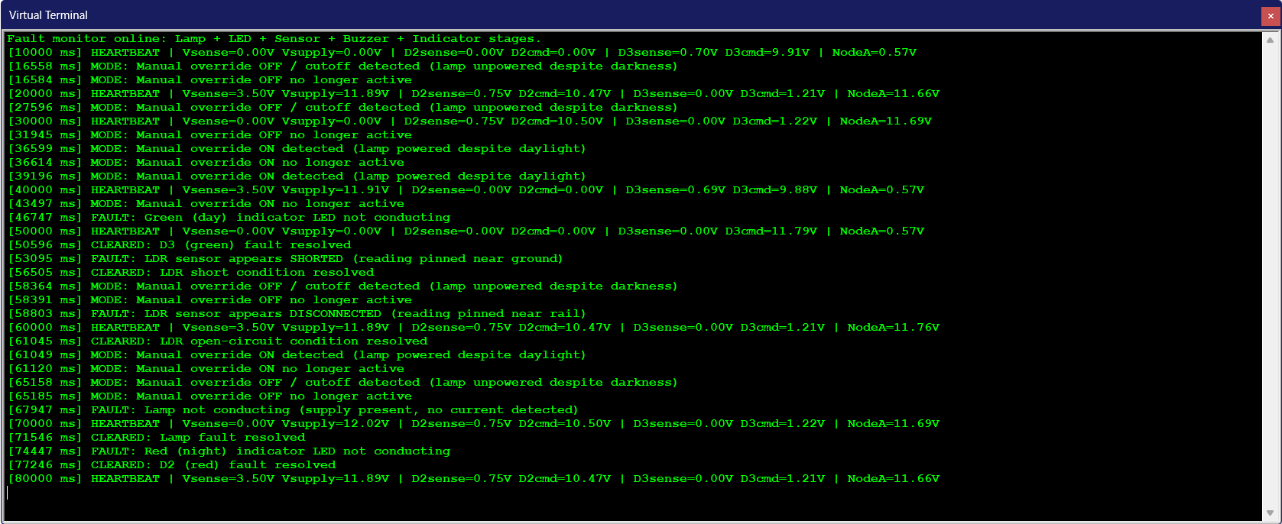Fig. 9 — Serial terminal captures: normal heartbeat, lamp fault, indicator LED faults, sensor faults, and override events, each detected and cleared.
Across all cases the subsystem behaved as designed: every genuine fault produced its message, its LED, and the buzzer; every intentional override was logged without an alarm; and every condition cleared correctly when resolved.
Table VIII — Fault-detection verification summary (simulation)
Condition injected | Expected response | Result
Lamp open (powered, no current) | LAMP fault + D4 + buzzer | Pass
Red LED failed while commanded on | D2 fault + D5 + buzzer | Pass
Green LED failed while commanded on | D3 fault + D6 + buzzer | Pass
LDR disconnected | SENSOR (open) + D7 + buzzer | Pass
LDR shorted | SENSOR (short) + D7 + buzzer | Pass
Forced ON in daylight | MODE log only, no alarm | Pass
Forced OFF in darkness | MODE log only, no alarm | Pass
All faults cleared | CLEARED messages, all off | Pass

The readings the thresholds were set from are listed below. These are simulation values and are not transferable to hardware — Section 9.5 shows what the same nodes actually read on the bench.
Table IX — Calibration data extracted from the simulation
Signal | Simulated value
Node A, bright | 0.55 – 0.57 V
Node A, genuine full dark | 11.66 V
Node A, LDR disconnected | 11.76 V
Node A, LDR shorted | 0.00 V
Sensor open threshold set to | 11.71 V
Lamp V_sense, lamp working | 3.50 V (≈ 350 mA)
Lamp V_supply, lamp lit | 11.89 V
D2 sense, conducting | 0.75 V
D3 sense, conducting | 0.70 V
D2 command, night | 10.47 V
D3 command, day (loaded) | 9.91 V
D3 command, night (Q1 saturated) | 1.21 V

9. Hardware Implementation
The design of Sections 2 to 8 was built as a physical breadboard prototype and demonstrated. Every voltage in this section was read from a multimeter or from the ESP32's own calibrated ADC on the physical board. Where a value was not measured, this section says so rather than substituting a simulation figure.

9.1 Choice of microcontroller and consequences
The simulation used an ATmega328P because Proteus models that chip directly and it takes the same compiled hex file as an Arduino Uno. The hardware uses an ESP32 DevKit V1 (WROOM-32), which was already owned, needs no external crystal, regulator or reset pull-up, carries a factory-calibrated ADC, and brings Wi-Fi — which made the dashboard of Section 9.7 possible at no extra hardware cost.
The substitution is not free. The ESP32 runs on 3.3 V logic and is not 5 V tolerant, so every tap into the microcontroller had to be resized. Its ADC inputs must also be restricted to the ADC1 bank (GPIO 36, 39, 34, 35, 32, 33), because ADC2 stops functioning whenever Wi-Fi is active — and the dashboard keeps Wi-Fi on permanently.
Table X — Summary of changes from simulation to hardware
Item | Simulation (Proteus 8) | Hardware (breadboard) | Reason
Fault-monitor MCU | ATmega328P | ESP32 DevKit V1 (WROOM-32) | Already owned; Wi-Fi; calibrated ADC; no support parts
Logic level | 5 V | 3.3 V, not 5 V tolerant | Every tap resized
Comparator | LM358 | LM358 (unchanged) | —
Supply rail | 12 V | 12 V (unchanged) | —
Load | 12 V filament lamp, relay NO contact | Red LED as the lamp; relay not populated | Safe low-power breadboard prototyping
Monitored channels | 7 taps | 2 analogue taps | Reduced to those carrying independent information
Node-A tap divider | 1 MΩ / 470 kΩ | 1 MΩ / 270 kΩ, gain 4.704 | 470 kΩ unavailable locally; gain recalculated
Lamp sense resistor | 10 Ω | 2.2 kΩ | ADC noise floor — see 9.6
Current-flow threshold | 0.30 V | 0.45 V | Re-derived from bench measurements
Fault indication | 4 dedicated LEDs | Onboard GPIO2 LED + buzzer | Reduced channel count
Remote reporting | none | Self-hosted Wi-Fi dashboard | Added feature

9.2 As-built analogue half
The analogue circuit is the design of Section 2, built on its own breadboard, and it runs entirely without the monitor. Unplugging the ESP32 leaves it working exactly as before.
- Sensing: R1 (10 kΩ) from +12 V to node A, LDR from node A to ground; C1 (10 µF) at node A.
- Reference: RV1 (10 kΩ) across the rail, wiper to the inverting input.
- Decision: one half of an LM358, open-loop, with R4 (100 kΩ) positive feedback.
- Driver and load: the comparator output drives a BC547; the red LED lamp sits in the switched path with Rsense (2.2 kΩ) in its return leg to ground.
Relay. The relay appears in the schematic and in the simulation because it is the correct topology for a real installation — it is the isolation boundary that lets a mains luminaire be switched without mains voltage ever reaching the 12 V control side. It is not populated on the physical breadboard, where a low-current DC LED load was used instead. This is a scoping decision for safe prototyping, and the control side would be unchanged if the relay were fitted. See Section 10.

9.3 As-built monitor half
Two read-only taps. Both are high-impedance and draw negligible current, so neither can disturb the node it measures. The monitor forms its own day/night opinion from node A rather than trusting the comparator it is meant to be checking.
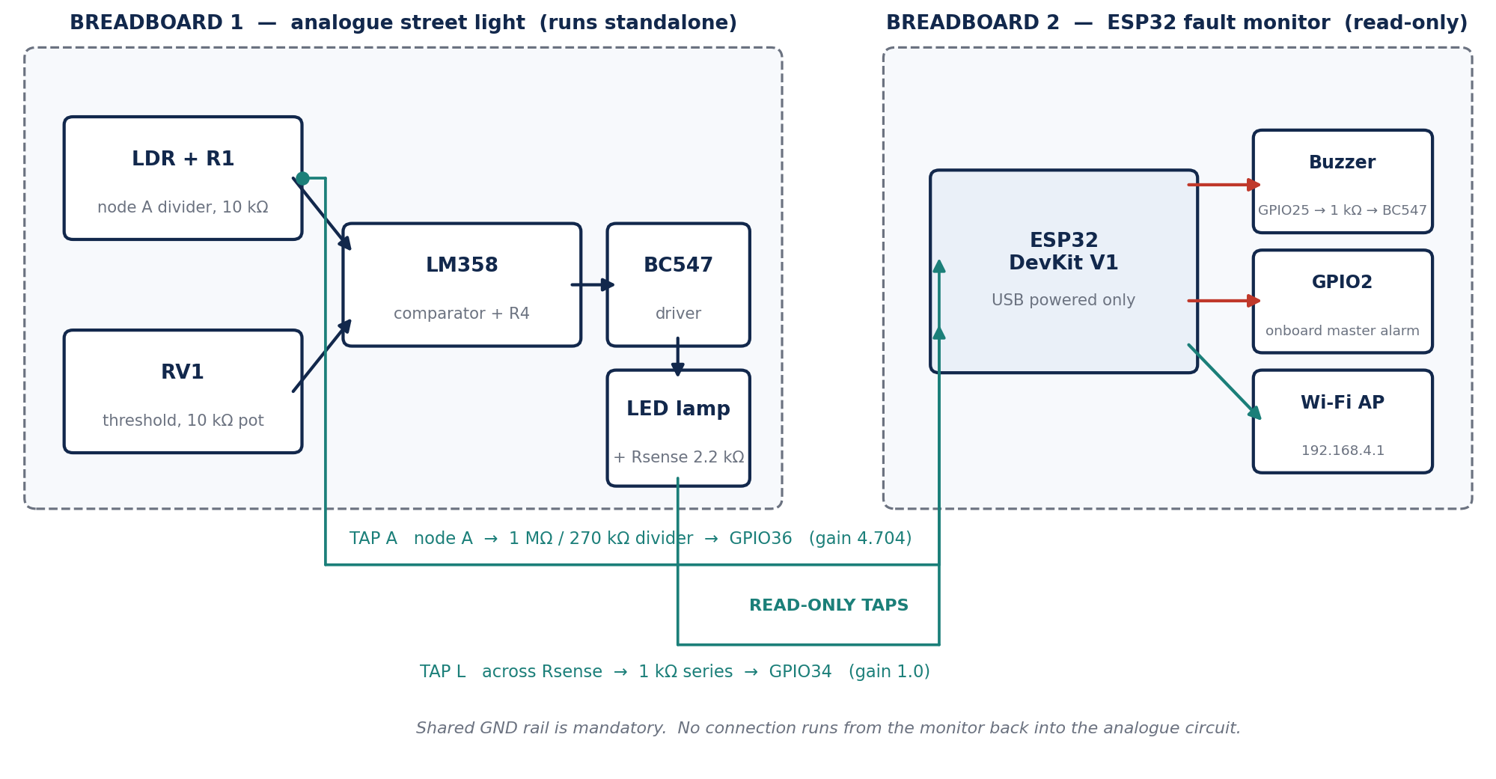
Fig. 10 — As-built hardware architecture: the analogue controller on one board, the ESP32 monitor on the other, joined only by two read-only taps and a common ground.
Table XI — ESP32 tap and pin map (as built)
Tap | Node measured | Interface | Pin | Software gain
A | Node A (R1 / LDR junction) | 1 MΩ / 270 kΩ divider (100 nF optional, omitted) | GPIO36 | 4.704
L | Lamp current, across Rsense | 1 kΩ series protection resistor only | GPIO34 | 1.0

Output | Function | Wiring
GPIO25 | Buzzer | 1 kΩ → BC547 base, emitter to GND, buzzer collector → +12 V
GPIO2 | Master alarm | Onboard blue LED — no external wiring
GPIO23 | Manual override | Spare pin, placeholder only — see 9.7
GND | Shared reference | Must connect to the circuit's GND rail

Two constraints that are not optional. The ESP32 is powered from USB only — 12 V on any ESP32 pin destroys the board instantly. And GPIO2 must be left unwired: it is a strapping pin read at power-up to select boot mode, so driving the onboard LED from software is fine but hanging an external load on it causes upload failures.
Divider safety check. Node A reaches 10.08 V measured at full dark. Through the 1 MΩ / 270 kΩ divider that is 10.08 / 4.704 = 2.14 V at GPIO36 — comfortably inside the 3.3 V limit, with headroom for a rail slightly above 12 V.

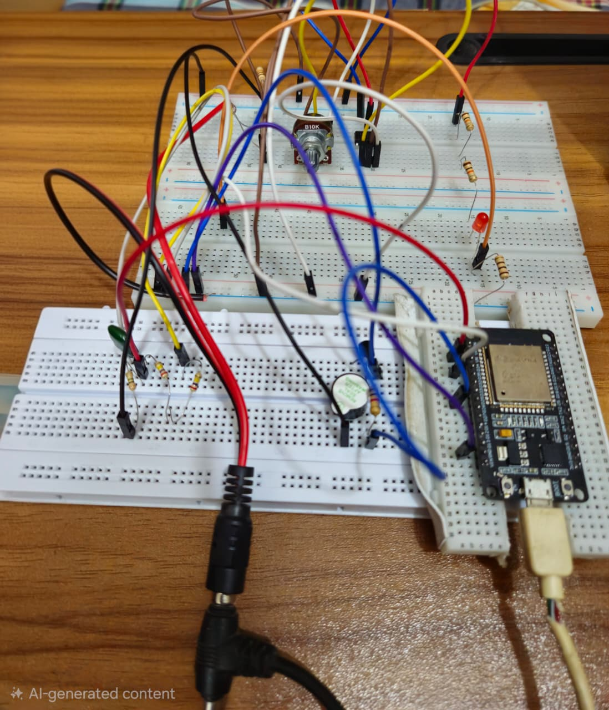
Fig. 11 — The assembled breadboard prototype: analogue controller and ESP32 fault monitor on separate boards, joined by the two tap wires and a common ground.

9.4 Calibration procedure
Three numbers cannot be known in advance because they depend on the specific LDR, the specific LED and the specific ADC. The firmware carries a CALIBRATION_MODE flag which, when set true, prints the raw node voltages continuously and does nothing else.
- V_DARK — read node A in bright room light and again with the LDR fully covered, and place the threshold between the two, near the point where the lamp actually switches.
- CURRENT_FLOW_V — read the voltage across Rsense with the lamp lit and with it dark, and place the threshold between them.
- SENSOR_HIGH_V — read node A with the LDR covered, then with the LDR physically pulled out, and take the midpoint.
Steps 1 and 2 were completed. Step 3 was not: the open-sensor threshold was never re-measured on the physical board and still carries its pre-build estimate. This is recorded as an open item in Section 11 rather than papered over.
Table XII — Calibrated hardware thresholds
Constant | Value | Basis
GAIN_A | 4.704 | (1 MΩ + 270 kΩ) / 270 kΩ — calculated from fitted parts
GAIN_LED | 1.0 | No divider on this tap
V_DARK | 6.00 V | Measured: node A 0.67 V daylight, 10.08 V full dark
CURRENT_FLOW_V | 0.45 V | Measured: 0.779 V lamp on, 0.003 V lamp off, across 2.2 kΩ
SENSOR_LOW_V | 0.30 V | Carried over. A shorted LDR pins node A to ≈ 0 V, so the margin is large.
SENSOR_HIGH_V | not re-measured | Outstanding — see Section 11

Readings use analogReadMilliVolts() rather than raw analogRead(), which applies the chip's factory ADC calibration and is materially more accurate. Node A is averaged over 64 samples per reading, the sense tap over 16.

9.5 Measured results
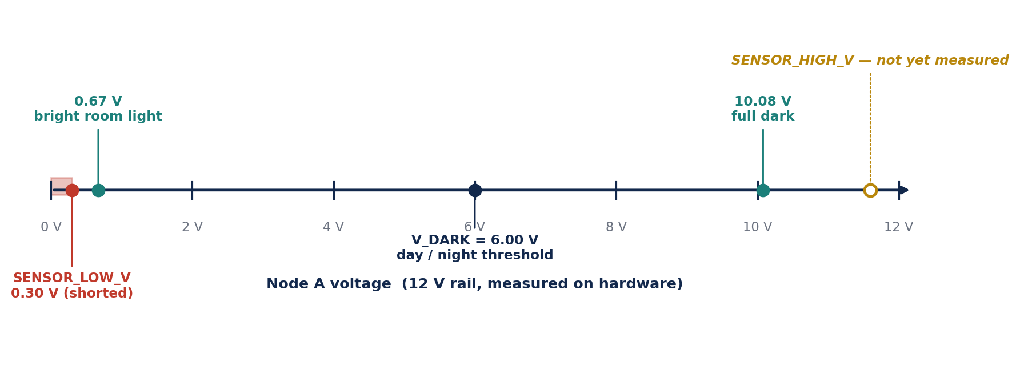
Fig. 12 — Node A measured operating map on the physical board, showing the day and dark readings, the calibrated day/night threshold, and the sensor limits.
Table XIII — Measured hardware data (12 V rail)
Quantity | Measured | Note
Node A, bright room light | 0.67 V
Node A, full dark | 10.08 V
Node A at GPIO36, full dark | 2.14 V (derived) | Confirms divider is safe
Rsense voltage, lamp on — 100 Ω | 38.8 mV | First build; unusable, see 9.6
Rsense voltage, lamp off — 100 Ω | 3.3 mV
Rsense voltage, lamp on — 2.2 kΩ | 0.779 V | Final build
Rsense voltage, lamp off — 2.2 kΩ | 0.003 V | Final build
Lamp current (derived) | ≈ 0.35 – 0.39 mA | 0.779/2200 and 0.0388/100 agree
ESP32 ADC noise floor, observed | ≈ 0.142 V | Observed as a stuck reading

Table XIV — Simulated versus measured
Quantity | Simulated | Measured | Comment
Node A, bright | 0.55 – 0.57 V | 0.67 V | Close; real LDR slightly more resistive in light
Node A, full dark | 11.66 V | 10.08 V | Real LDR dark resistance below the model's ≈ 447 kΩ
Reference V(−IP) | 6.00 V | Set by RV1 in the field | Pot recalibrated as anticipated in 2.3
Lamp sense, conducting | 3.50 V | 0.779 V | Different load entirely — 0.35 mA vs 350 mA
Control current, night | ≈ 63.2 mA | Not measured | Dominated by the relay coil, not populated

The lamp figures deserve emphasis. The simulated load draws roughly one thousand times the current of the physical one. Every current-derived figure in Sections 7 and 8 describes the simulated circuit and does not describe this board. That single discrepancy is the origin of the calibration failure described next.

9.6 Principal hardware finding — a measurement floor, not a threshold error
This is the part of the build that the simulation could not have predicted, and it is the most useful engineering result in the project.
Symptom. With the lamp lit at night, the monitor reported a burnt-out lamp continuously.
First diagnosis — correct but insufficient. CURRENT_FLOW_V was 0.30 V, inherited from the simulation where the lamp developed 3.50 V across the sense resistor. The real lamp developed 38.8 mV. The threshold sat far above any voltage the real circuit could produce, so “no current” was reported permanently. Lowering the threshold to 0.020 V — between the measured 38.8 mV and 3.3 mV — cleared the false daytime alarm.
Second diagnosis — the real one. The fault returned. The ESP32's ADC has a noise floor of roughly 0.142 V: the pin returns approximately that value regardless of what is applied below it. Both the lamp-on reading (38.8 mV) and the lamp-off reading (3.3 mV) sit underneath it. The two states were not badly separated — they were not measurable at all.
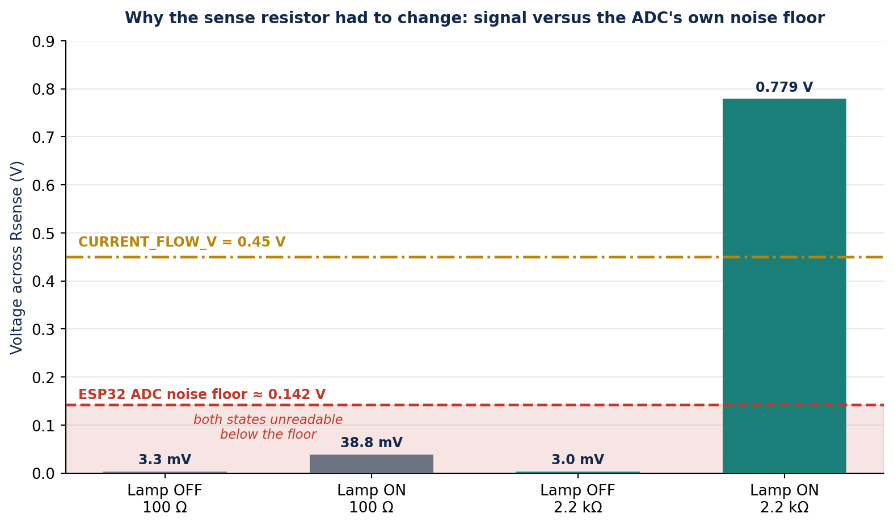
Fig. 13 — The measured sense voltages against the ESP32's ADC noise floor, before and after the sense resistor was changed from 100 Ω to 2.2 kΩ.
Why no software change could fix it. Averaging, filtering and re-thresholding all operate on a signal that has already been destroyed by the instrument's own noise. Once a measurement falls below the noise floor of the device taking it, no amount of processing recovers it.
The fix was hardware. Rsense was changed from 100 Ω to 2.2 kΩ. The same ≈ 0.35 mA lamp current now develops 0.779 V, a factor of twenty above the noise floor; lamp-off reads 0.003 V. The threshold was set to 0.45 V, roughly midway and clear of both. Fault detection was then verified end to end.
The general lesson. A threshold can only be calibrated inside the measurable range of the instrument. Sizing a sense resistor is not only about minimising its intrusion into the circuit — it is about placing the resulting signal where the ADC can actually see it. The simulation gave no warning of this because an ideal simulated ADC has no noise floor.

9.7 Wi-Fi monitoring dashboard
The ESP32 hosts its own access point, so the system needs no router, no internet connection and no cloud service. Anything with a browser can connect directly.
Setting | Value
SSID | StreetLightMonitor
Password | streetlight
Address | http://192.168.4.1 (fixed)

The page serves live node-A and sense voltages, the current DAY / DARK state as the monitor judges it, a 60-second rolling history graph, the fault log carrying the same events as the serial output, and a manual override button.
The override button is a deliberate placeholder and is labelled as such. It toggles spare GPIO23 only; that pin is not connected to the lamp path. Making it functional requires two things that were not built: a switching element in the lamp path that the ESP32 can drive, and override-aware fault logic so that an intentional shut-off is not reported as a burnt-out lamp. Until both exist, wiring the button to the lamp would violate the project's central rule from Section 8.1 — that the monitor never drives the circuit it watches.
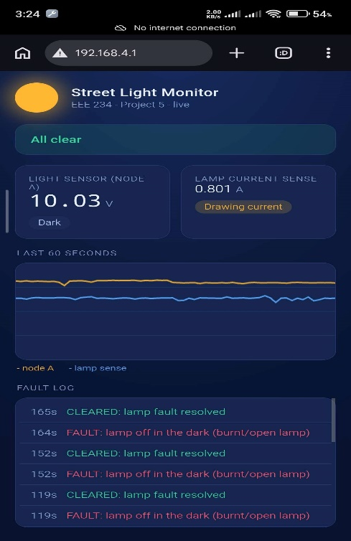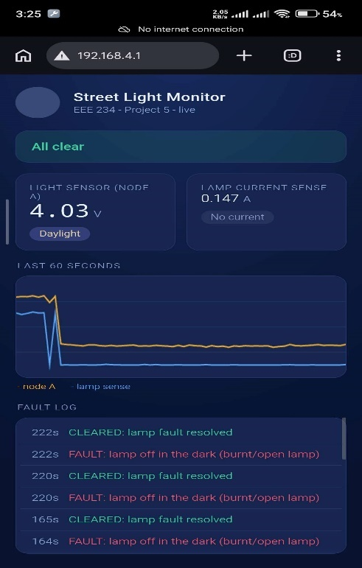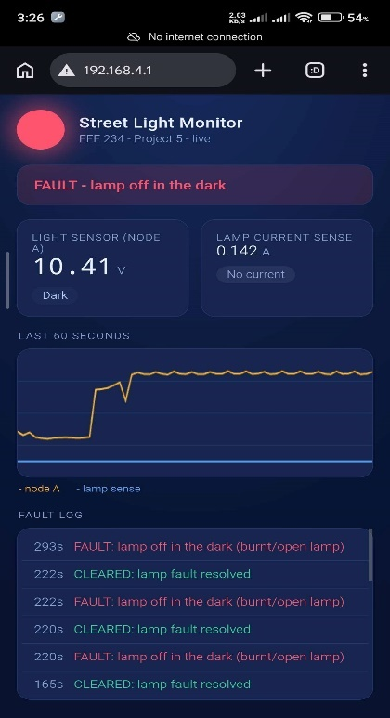
Fig. 14 — The Wi-Fi dashboard as served from the ESP32: live values, rolling history graph and fault log.

9.8 Functional verification on hardware
Table XV — Hardware verification
Test | Expected | Result
Day/night detection from node A | DAY at 0.67 V, DARK at 10.08 V | Pass
Lamp conducting, correctly recognised | Sense 0.779 V > 0.45 V → no fault | Pass
Lamp open while dark | Sense ≈ 0.003 V → lamp fault, buzzer, GPIO2 | Pass
Fault clears when lamp restored | CLEARED message, alarm off | Pass
Wi-Fi AP reachable, dashboard live | Page served at 192.168.4.1 | Pass
Monitor removal leaves controller working | Street light unaffected | Pass
Sensor shorted (LDR jumpered) | SENSOR shorted message | Not yet verified
Sensor open (LDR removed) | SENSOR disconnected message | Not yet verified

9.9 Build and reproduction notes
- Board selection: Arduino IDE → Tools → Board → ESP32 Dev Module. Not ESP32C3 Dev Module, which was tried first and does not work with this hardware.
- Driver: this board uses a Silicon Labs CP210x USB-to-serial chip. Without the CP210x VCP driver installed, no COM port appears at all.
- Upload sequence if it stalls on Connecting: hold BOOT, tap EN/RST once while still holding BOOT, release BOOT, then start the upload immediately.
- A charge-only USB cable looks exactly like a dead board. Use a data cable.
- Serial monitor at 115200 baud. The Wi-Fi details print once at boot, so they will have scrolled past if the monitor is opened afterwards — press EN/RST to replay them.
- No blue LED activity and no response to EN are normal on a board with no firmware loaded, and are not evidence of a fault.
- The 100 nF capacitor on the GPIO36 tap is optional and was omitted; the 64-sample averaging does the same job.

10. Discussion and Limitations
The simulation validates the design and the hardware confirms its core behaviour, but several limitations should be stated plainly.
The simulated LDR is not a real device. The TORCH_LDR is an idealised Proteus model with a dark resistance around 447 kΩ, far above the ≈ 100 kΩ textbook figure, so the numerical trip points derived in Section 2 shift on hardware and RV1 requires recalibration. This was borne out: node A read 10.08 V at full dark on the bench against 11.66 V in simulation.
The sensor-disconnection check has almost no margin. Because the dark LDR's resistance is so much larger than R1, the sensing node already sits close to the supply rail in genuine darkness, leaving only about a 0.10 V gap between “truly dark” (11.66 V) and “disconnected” (11.76 V) in simulation. In a deterministic simulator with no electrical noise, a threshold placed midway separates the two reliably. On real hardware, with thermal drift and component tolerance present, so narrow a margin cannot be trusted. A robust hardware version of this check needs either a different sensing arrangement that widens the gap, or per-unit calibration against the specific LDR's measured dark resistance. This is a genuine constraint of the method, not a defect in the implementation. On the physical board this threshold has not yet been calibrated at all.
The physical load is not a street lamp. It is a red LED drawing roughly 0.35 mA, against the simulation's ≈ 350 mA filament lamp. The prototype demonstrates the sensing, decision and monitoring layers; it does not demonstrate the power stage.
The relay is not populated on the breadboard, so the isolation property that motivates it in Section 2.7 is present in the design but not exercised in the build. The control side would not change if it were fitted, which is the point of putting the boundary there.
The whole system is DC. Supply, sensing and load are DC throughout. A real AC luminaire would need a mains-rated contact, an AC current sensor — peak detection, precision rectification using the spare half of the LM358, or software RMS sampling — and proper isolation between the mains side and the microcontroller. The control and monitoring logic carries over unchanged; the front end does not.
Fault coverage is narrower in hardware than in simulation. The seven-tap simulated monitor distinguished lamp, red-LED, green-LED and sensor faults separately, with a dedicated indicator for each. The two-tap hardware monitor covers lamp and sensor faults with a single master alarm.
The filtering action of C1 was never demonstrated directly, in simulation or on hardware, because a manually operated light source moves far more slowly than the 48 ms time constant it is designed to reject. Its presence is justified analytically in Section 2.5 but a transient graph driven by an injected pulse would be required to show it.
The relay remains the weakest element in reliability terms in the full design. It is the only moving part, it wears mechanically over tens of thousands of operations, and it draws 43 mA continuously whenever the lamp is lit — more than the entire rest of the control circuit combined.

11. Future Work
Outstanding on the current build
- Measure SENSOR_HIGH_V on the physical board with CALIBRATION_MODE = true: node A with the LDR covered, then with it removed, threshold at the midpoint.
- Verify the sensor short and sensor open faults end to end on hardware once that threshold is set.
Extensions
- Functional manual override: add a switching element in the lamp path that the ESP32 can drive, plus override-aware fault logic, so the dashboard button controls the lamp without the monitor being able to cause a fault.
- Fit the relay and re-verify with a mains-class load and appropriate creepage and contact ratings.
- Restore per-fault indication — the four dedicated fault LEDs of the simulated version — now that spare GPIO is available.
- Transient verification of the input filter: inject a pulse into the sensing node through a series resistor and plot the raw pulse against the filtered node voltage, to demonstrate the 3.3 Hz roll-off directly.
- Turn-on delay stage: use the unused second amplifier of the LM358 (U1:B) with a slow RC network to require darkness to persist for two to three seconds before switching.
- Solid-state switching: replace the relay with a logic-level MOSFET, eliminating the mechanical wear and the 43 mA coil current at the cost of galvanic isolation. For a mains lamp, a triac with an opto-isolated gate driver would preserve isolation.
- Supply protection: series reverse-polarity diode and a fuse at the supply input.
- Field calibration against a lux meter, so the trip point can be specified in lux rather than as a potentiometer position.
- Non-volatile fault logging with real timestamps, and reporting over a network link so a central office is notified without a site visit.

12. Conclusion
A light-activated automatic street light controller was designed, analysed, simulated in Proteus 8, and built as a physical prototype.
The design uses an LDR divider and one half of an LM358 as a comparator, with the switching threshold set by a potentiometer. Three refinements raise it above a minimal comparator circuit: positive feedback through a 100 kΩ resistor produces a 0.53 V hysteresis band that prevents chatter at dusk; a 10 µF capacitor at the sensing node gives a 3.3 Hz roll-off that rejects brief optical disturbances; and a two-switch arrangement provides a genuine three-state manual override capable of forcing the lamp both on and off independently of the sensor. The output stage drives a relay through a saturated BC547 with a forced beta of 4.4 and a properly oriented freewheeling diode, and the lamp is taken from the normally-open contact so that it lights only in darkness. The netlist passed Electrical Rule Check without error, all four operating states were verified, and the measured hysteresis band agreed with the design equations to within 6 %.
Building on this, a microcontroller-based fault-detection subsystem was added that monitors the circuit's own health without altering its operation. Simulated on an ATmega328P, it detects a failed lamp, a failed indicator LED, and an open or shorted sensor, alerts through a buzzer and per-fault LEDs, keeps a timestamped log, and distinguishes genuine faults from intentional overrides. All fault types were injected and correctly identified.
The design was then implemented in hardware on an ESP32 DevKit V1, with the input dividers resized for 3.3 V logic and the monitor reduced to two independent taps. Day/night detection and lamp-fault detection were verified end to end on the physical board, and the ESP32 serves a self-hosted Wi-Fi dashboard giving live readings, a rolling history graph and a fault log to any phone on its access point.
The hardware also produced the project's most useful result, and one the simulation could not have given. Fault thresholds calibrated against a simulated 350 mA lamp were meaningless against a real 0.35 mA LED, and lowering them did not help, because both the lamp-on and lamp-off readings sat beneath the ESP32's own ADC noise floor of approximately 0.142 V. The signal had not been mis-thresholded; it had been made unmeasurable. The fix was a hardware change — a 2.2 kΩ sense resistor in place of 100 Ω — which lifted the signal twenty times clear of the floor and allowed a threshold to be set from real measurements.
Together, the base controller, the monitoring layer and the physical build form a design that not only switches a street light automatically but also reports when it can no longer do so, and a build that demonstrates why a validated simulation is a starting point for hardware rather than a substitute for it.

References
[1] A. S. Sedra and K. C. Smith, Microelectronic Circuits, 7th ed. New York, NY, USA: Oxford Univ. Press, 2015.
[2] R. L. Boylestad and L. Nashelsky, Electronic Devices and Circuit Theory, 11th ed. Boston, MA, USA: Pearson, 2013.
[3] P. Horowitz and W. Hill, The Art of Electronics, 3rd ed. Cambridge, U.K.: Cambridge Univ. Press, 2015.
[4] Texas Instruments, “LM158, LM258, LM358, LM2904 dual operational amplifiers,” LM358 datasheet.
[5] ON Semiconductor, “BC546/BC547/BC548 general-purpose NPN transistors,” BC547 datasheet.
[6] Vishay Semiconductors, “1N4001 through 1N4007 general-purpose plastic rectifiers,” datasheet.
[7] Omron Electronic Components, “G2R series PCB power relay,” datasheet.
[8] Labcenter Electronics, Proteus Design Suite 8: Schematic Capture and Simulation User Manual.
[9] Espressif Systems, “ESP32 Series Datasheet” and “ESP32 Technical Reference Manual.”

Appendix A — Added Components for the Fault-Detection Subsystem
Table XVI lists the components added for the fault-detection subsystem in simulation. These are additional to the base components listed in Table II.
Table XVI — Added components for the fault-detection subsystem (simulation)
Ref. | Device | Value | Function
U2 | ATMEGA328P | — | Fault-monitoring microcontroller.
X1 | CRYSTAL | 16 MHz | Clock source for U2.
C2, C3 | CAP | 22 pF | Crystal loading capacitors.
C4 | CAP | 100 nF | Decoupling for the reference pin.
B2 | BATTERY | 5 V | Separate logic supply for U2.
R8 | RES | 10 kΩ | Reset pull-up for U2.
Rsense | RES | 10 Ω | Lamp current-sense resistor.
R9, R10 | RES | 100 Ω | Indicator-LED current-sense resistors.
R15, R16 | RES | 1 MΩ / 470 kΩ | High-impedance divider for the sensing-node tap.
R17–R20 | RES | 220 Ω | Current limiters for the four fault LEDs.
D4–D7 | LED | — | Per-fault indicator LEDs (see Table VII).
BUZ1 | BUZZER | — | Audible fault alarm.
SW4, SW5 | SW-SPST | — | Test switches to inject indicator-LED faults.
SW6, SW7 | SW-SPST | — | Test switches to inject sensor open/short faults.

SW4–SW7 exist to demonstrate and exercise the fault conditions in simulation; a deployed unit would monitor the same nodes without the fault-injection switches.

Appendix B — Firmware
Full listings are supplied as separate files in the repository rather than inline, so that the code in this report cannot drift out of step with the code that is actually compiled.
File | Target | Notes
fault_monitor.ino | ATmega328P | The version simulated in Proteus. Seven taps, four fault LEDs, override recognition. All eight checks of Table VIII verified.
fault_monitor_atmega.ino | ATmega328P (hardware port) | Six-channel version. The DIP-28 package has only ADC0–ADC5; the comparator output and Q1 collector are exactly complementary, so one is measured and the other inverted. Exact, not an approximation.
fault_buzzer_esp32_12v.ino | ESP32 DevKit V1 | The build documented in Section 9. Two taps, buzzer and master LED.
Wi-Fi revision of the above | ESP32 DevKit V1 | Adds the access point and dashboard of Section 9.7. Thresholds unchanged.

The calibrated constants from the ESP32 build, for reference:
// ---------- pins (both ADC pins are on ADC1, required with Wi-Fi active) ----------
const int PIN_NODE_A = 36; // node A, via 1M / 270k divider
const int PIN_LED_CUR = 34; // Rsense voltage, via 1k
const int PIN_BUZZER = 25; // 1k -> BC547 -> buzzer
const int PIN_MASTER = 2; // on-board LED

// ---------- divider gains ----------
const float GAIN_A = (1000.0 + 270.0) / 270.0; // = 4.704
const float GAIN_LED = 1.0; // no divider on this tap

// ---------- thresholds, in REAL circuit volts ----------
float V_DARK = 6.00; // measured: 0.67 V day, 10.08 V dark
const float CURRENT_FLOW_V = 0.45; // measured: 0.779 V on, 0.003 V off
const float SENSOR_LOW_V = 0.30; // shorted LDR pins node A near 0 V
float SENSOR_HIGH_V = /* OUTSTANDING - measure on hardware */;

